# HR Onboarding PowerApps Sample

## Overview

The HR Onboarding App is designed to streamline and simplify the process of bringing a new employee onboard into the organization. In many organizations, onboarding new employees can be a complicated and laborious process. Multiple departments are typically involved leading to missed steps and other delays. In the past, Contoso has left many employees waiting for days to receive the equipment and training necessary for day-to-day work, such as their primary laptop computer, or training on key operating systems. In a few cases, this has meant that new employees are waiting for up-to a week to begin any actual work. After reviewing the current on boarding process, as well as feedback from employees and department heads, Contoso management has authorized the creation of a new business application to improve the entire on boarding experience for both new employees and the business.

## Device Support

HR Onboarding is available in both the Tablet and Phone form factors.

### Tablet

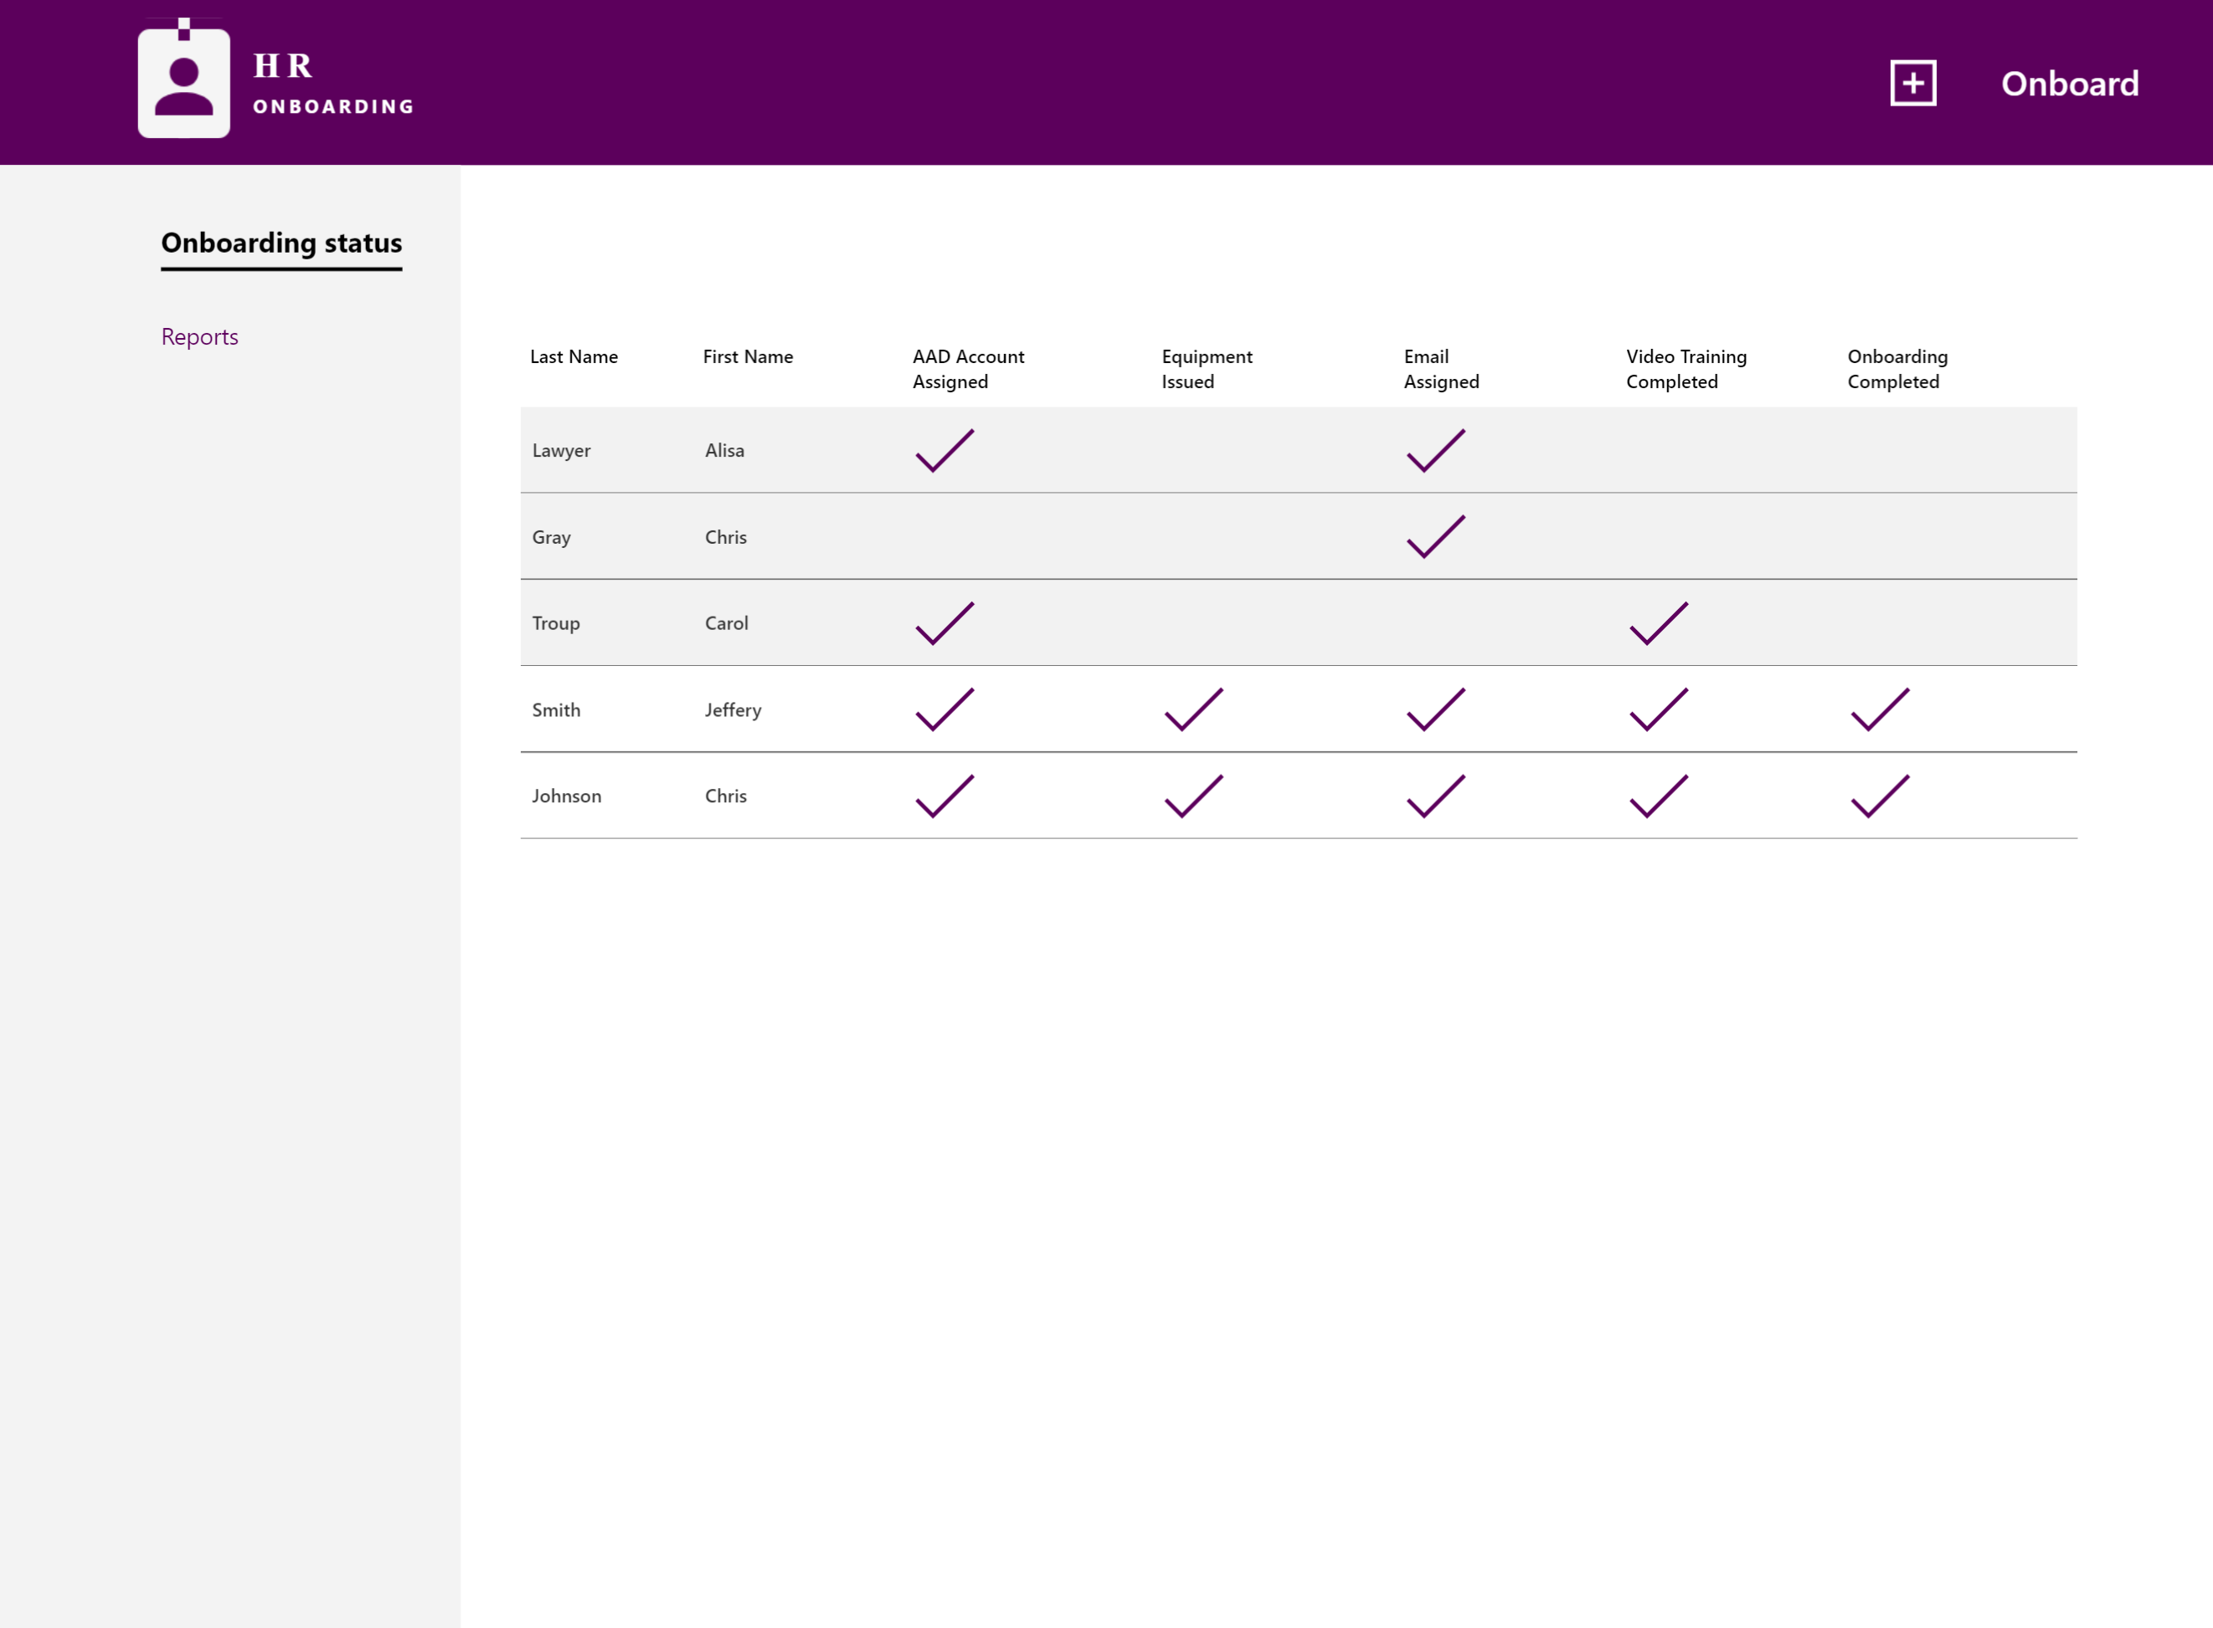

### Phone

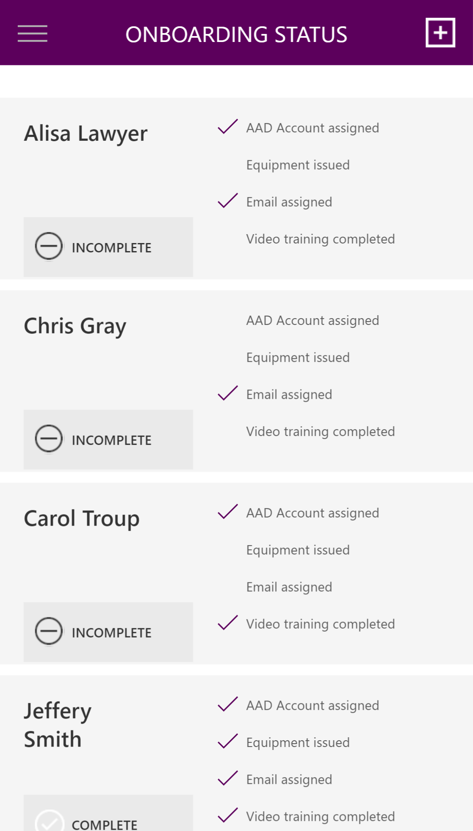

## Show me!

Watch **this video** to see an end-to-end demonstration of the functionality.

## Getting Started

See the installation instructions and **video** that describe and demonstrate how to install and set it up.

## Technical Details

### Connectors

HR Onboarding uses the following Connectors to access Office 365 Services.

* [Office 365 SharePoint](https://docs.microsoft.com/en-us/connectors/sharepointonline/)

We hope you enjoy HR Onboarding and look forward to hearing how you extend it for your organization!